|  |
| --- |
| **Software Version Description**  **(SVD)** |
| ***for the***  ***DLS Project***  ***Bluetooth application***  Prepared for:  Elbit Systems Ltd.  Prepared by:  Comm-IT ,20 Hamagshimim St. Petach Tikva 49348, ISRAEL |

**TABLE OF CONTENTS**

1. SCOPE 3

1.1 System Overview 3

1.2 Document Overview 4

1.3 Installation instructions 4

1.3.1 Development tools and environment (IDE) 4

1.3.2 Installation files location on the web 4

# SCOPE

The Software Version Description (SVD) identifies and describes the released version of the DLS project: Bluetooth application.

## Identification

System name: DLS Bluetooth application.

System abbreviation: DLS

CSCI number:

CSCI Name:

CSCI abbreviation:

CSCI version number:01-04

CSCI version issue date: 03.04.18

Software checksum: not required

## System Overview

The DLS (Digital Lethality system) system is hardware device that build to carry on light weapons. This system provides the warrior in combat zone to view data on the weapon sight such as: friendly zones, enemy zones and self-location. The product will present those data throw the natural view of the weapon without any interference on it. The product also has ability to communication nearby communications device using internal Bluetooth hardware and application which add the ability to transfer data in real time between warriors and commanders.

This application provide an Ethernet communication based Bluetooth (up to Bluetooth version 4.0) physical layer. It provides the ability of transferring data such as: points location, maps, etc. over a speed that up to 24.0 Mbit / sec (on Bluetooth version 3.0 HS) between shared devices. Over this Ethernet infrastructure Elbit Tiger system is operating.

The major functions of the Bluetooth application are:

* Provide Ethernet physical layer for transferring data between shared systems.
* Provide Ethernet interface for Elbit Tiger system.

In the following figure, the DLS system is illustrated:

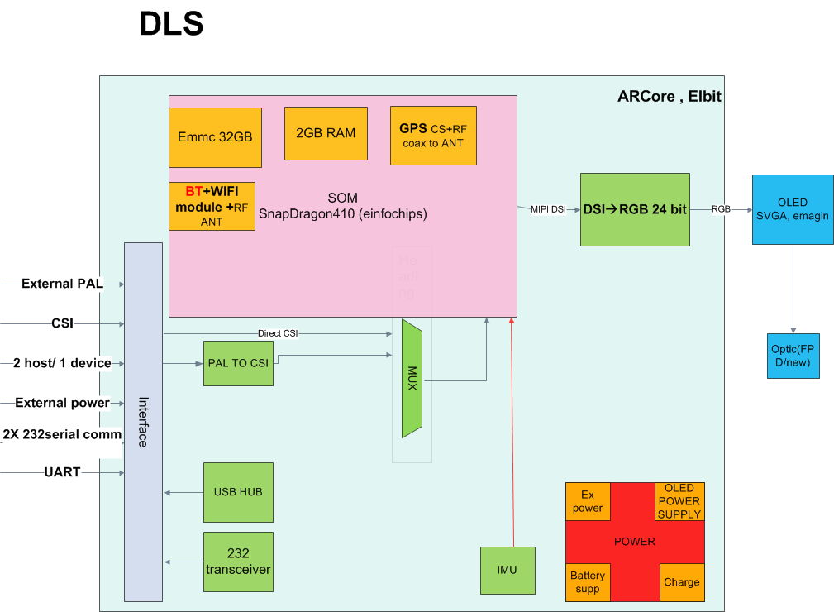

## Document Overview

The SVD identifies and describes the released version of the Bluetooth application.

The documentation listed in paragraph 2.2 provides a detailed description of the software.

This SVD is structured as follows:

| Section | Contents |
| --- | --- |
| Section 1 | Scope of this document |
| Section 2 | All documents referenced by this SVD |
| Section 3 | Version description |
| Section 4 | Notes and Acronyms |
| Appendix A | Lists the files for this CSCI |

# Referenced Documents

## Government Documents

|  |  |  |  |
| --- | --- | --- | --- |
| **#** | **Title** | **Description** | **Date** |
|  |  | SOFTWARE VERSION DESCRIPTION (SVD) | 03/04/2018 |

## Project Documents

|  |  |  |  |  |
| --- | --- | --- | --- | --- |
| **#** | **Doc. ID** | **Title** | **Revision** | **Date** |
|  |  |  |  |  |
|  |  |  |  |  |
|  |  |  |  |  |

## Other Documents

|  |  |  |  |  |
| --- | --- | --- | --- | --- |
| **#** | **Doc. ID** | **Title** | **Revision** | **Date** |
|  |  |  |  |  |
|  |  |  |  |  |

# Version Description

## Inventory of Materials Released

None materials release

## Inventory of Software Contents

The release contains the following files:

|  |  |  |  |
| --- | --- | --- | --- |
| **File Name** | **Size** | **Date** | **Comment** |
| DLS_BT_APP_SRC_01_04.zip | 29,067,264 bytes | 03.04.18 |  |

The released version contains the CSCI’s files listed in appendix A.

## Changes Installed

## Class I Changes Installed

NA

## Class II Changes Installed

NA

## Changes Effects

NA

## Adaptation data

No adaptation is required

## Related Documents

The following table lists the associated documentation that makes up the new version, and the operation and support documents that are not a part of the delivered package, but required to operate, load, or regenerate the CSCI.

|  |  |  |  |  |
| --- | --- | --- | --- | --- |
| **#** | **Doc. ID** | **Title** | **Revision\*** | **Date** |
|  |  | DLS BT APP SVD | 01 | 04.03.18 |
|  |  | DLS BT APP PR | 01 | 04.03.18 |

* The referenced documents' revision estate the applicable revisions relevant for this SW version on its release date.

CLASS II changes for these documents will not accompanied with new SVD revision.

Other SW versions relevant for the proper functionality of this CSCI version are listed in the following table:

|  |  |  |  |
| --- | --- | --- | --- |
| **#** | **SW Name** | **SVD/VDD Revision (in PLM)** | **Remarks** |
|  |  |  |  |
|  |  |  |  |

## Installation instructions

## Development tools and environment (IDE)

In order to working with the below tools we first need to root our device (describe latter).

The Android development tools called Android studio (describe latter) and ADB shell.

During building the Bluetooth application we use the following version of those tools:

1. Android Studio:
   1. version 2.2.3
2. ADB (Android debug bridge):
   1. version 1.0.32
   2. Revision eac51f2bb6a8-android

## Installation files location on the web

1. Android Studio: <https://developer.android.com/studio/index.html>
2. ADB Shell: <http://adbshell.com/downloads>

* 1. Root our Android device

In order to root our Android device we need to enable the “debug” option via the android options. On most Android devices that option can be found at:

Android options -> Developer options -> USB debugging.

We can also use 3d party applications such as: Kingo root (that can be found at: <http://www.kingoapp.com> There application isn`t official and released by Google).

* 1. **Working with the software:**

In the following part will provide a self instruction on how to build, compile and use the Bluetooth application software part:

* + 1. Working with Android Studio:
       1. Open the software project:

File -> Open -> Choose project location -> click OK

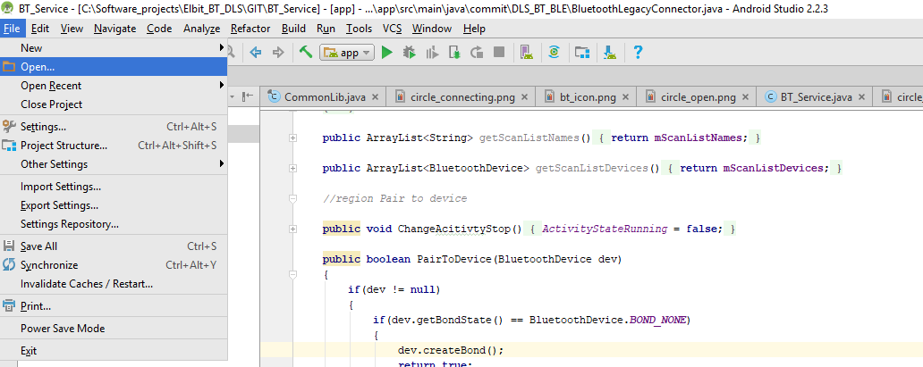

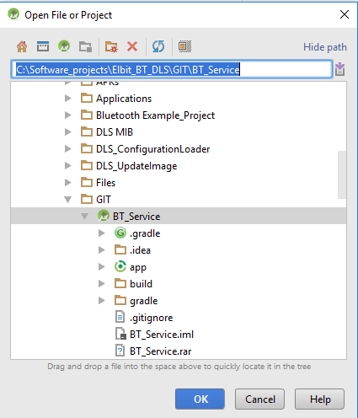

After click OK the project will be compile, build and the IDE will prepare the necessary files (Gradles files) for using.

To check if everything is build ok we can navigate to Android project view (in the left corner) and see our project files.

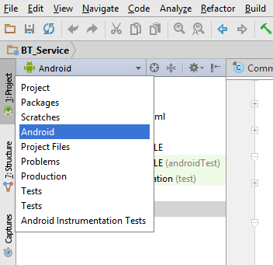

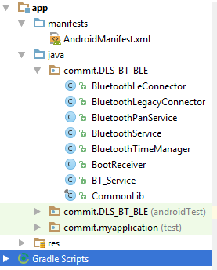

* + - 1. Build our project

In order to build the project: In IDE toolbar -> Click make project

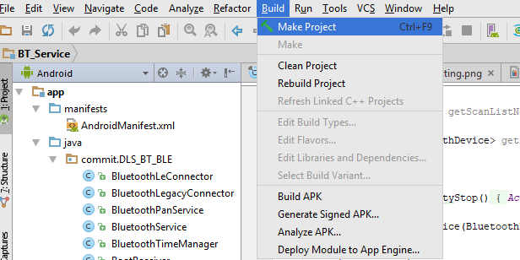

In this point if we will have issues that will appear in the bottom screen (message Gradle screen).

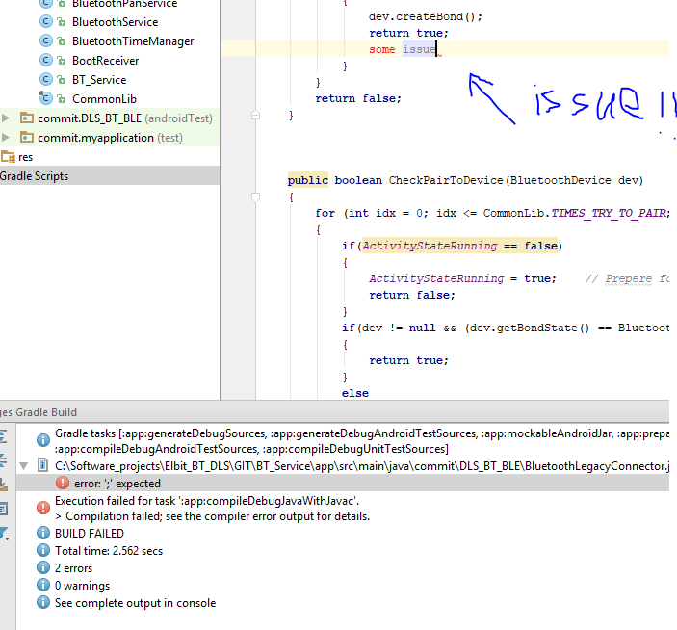

* + - 1. Make project APK

If build the project is ok (there are no compilation errors) we can export the project in APK (Android application package) file that can be move to our target and ready to run.

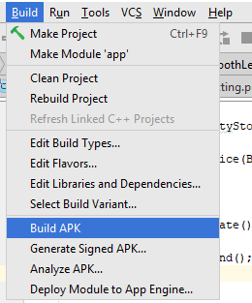

This will create not protect APK file, if we prefer protected file please choose “Generate signed APK…” option.

If the file created ok, we should get a message in the bottom of the screen (event log screen) that includes link to the APK path.

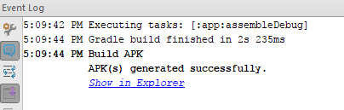

* + - 1. Program the target with build application:

If build was preform and ok we can program the device with build version.

Run -> Run ‘app’



* + 1. Working with ADB:

Beside Android Studio there is another option to program the device or to delete existing APK that already installed on the device.

Install APK: ADB shell command: adb install /path/to/app.apk

Uninstall APK: adb uninstall <package_name>

# APPENDIX A - Contents of CSCI files

List of files for the DLS Bluetooth application can be found at the file “DLS_BT_1_04_LIST_FILES.txt”